1. The soil C pool data was calculated from bulk density and soil organic matter from Table 3.

The paper does not report carbon density directly. We calculated carbon density from Table 3, which reported percent organic matter and bulk density, but not carbon pool.

a. Convert organic matter (OM) to organic carbon units.

We used the following equation developed by James Holmquist (in review):

SoilCC=0.074*(OM/100)*(OM/100) + 0.421*(OM/100) - 0.0080, where

SoilCC = C concentration in units of grams C per grams soil

OM = organic matter concentration in units of grams OM per grams soil

b. Convert soil carbon concentration (SoilCC) to carbon density.

SC=SoilCC*BD, where

SC=Soil carbon density in units of grams carbon per cubic centimeter (g/cm3)

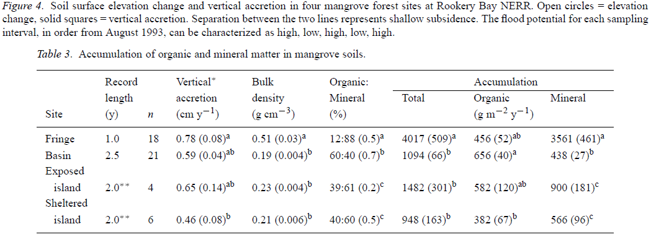

2. Soil C rate data was calculated from soil C pool and vertical accretion rate from Table 3.

Soil C rate= SC * SC_rate*10000, as SC_rate was cm/yr. Soil C rate unit is g C m2 /yr.